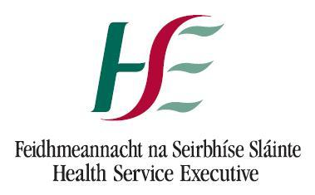
National Doctors Training and Planning
Health Service Executive
Dr. Steevens’ Hospital, Dublin 8
T: (01) 6352500 F: (01) 6352898
E: doctors@hse.ie
www.hse.ie/doctors

POST CSCST FELLOWSHIP JULY 2022
Approval Form

Title of Proposed Post
Proposing Training Body
Site / Employer
Subspecialty
Brief description of the proposed fellowship

Please indicate that the training body confirms the proposed fellowship adheres fully to the following conditions:

Conditions | Yes/No
The proposed posts provide a structured certifiable educational experience immediately following CSCST, designed to deliver the requirements of a particular subspecialty which are not readily available within the specialist training programme
The proposed posts have been evaluated and approved by the appropriate training body
Where appropriate, the posts fulfil training body requirements for Medical Council specialist registration (e.g. Intensive Care Medicine) and HSE employment requirements for consultant posts
The posts will not impinge on the training of pre-CSCST trainees
The posts have a supervisor assigned, with authority and accountability for the fellowship post
The posts will provides opportunities for audit and research
The posts will be filled under the auspices of the relevant Irish postgraduate medical training body
Candidates will be within 2 years of post CSCST

Signature on behalf of Training Body

Print Name

Date

Notes
Please note the following:
- In order to ensure that the clinical area of the fellowship post remains relevant to health service planning and medical workforce requirements a register is maintained by HSE-NDTP and reviewed on an annual basis.
- Following approval of a post-CSCST fellowship post, the Training Body is required to inform the site and HSE-NDTP when a candidate has been identified for position, the start date and the duration of the fellowship.
- Fellowship posts will not necessarily be occupied each year.
- HSE-NDTP maintains a register of all post-CSCST fellowships. Should a candidate withdraw from the fellowship, etc this should be brought to the attention of HSE-NDTP.

Approval is confirmed for the proposed post subject to the conditions outlined above. |  | Yes No
If no, comment

Signature on behalf of HSE - NDTP

Date

For Office Use Only:
Received By: |  |  | Date of receipt:
Date application made to HSE-NDTP:
Date approved:
Date of review:
Notes:

